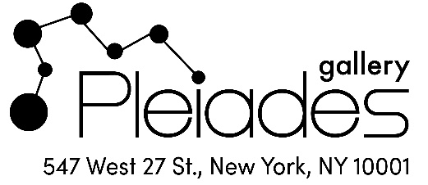
Tyler Anbinder to Speak at Pleiades Gallery on June 15, 2024

Pleiades Gallery will present a fascinating live program called “City of Dreams” that will connect the art exhibition, Heather Stivison: Borders and Boundaries to New York City’s colorful immigrant history. The exhibition, which will be on view June 11-July 6, presents a complex tapestry of drawings, paintings, textiles, and found objects that create visual narratives on borders, boundaries, and the basic human need for a place to call home. The artworks, all by Heather Stivison, have been inspired by contemporary and historical migration and border wars. In conjunction with this exhibition, author and historian Tyler Anbinder will discuss his research into the 400-year history of immigrants in New York City. The program will include a dialogue between artist and historian.

The interdisciplinary program will take place on Saturday, June 15, 2024, at 3:30 p.m. at Pleiades Gallery, 547 West 27th Street, Suite 304, New York, NY 10001. The gallery is situated in the Landmark Arts Building, steps away from the entrance to the High Line in the Chelsea gallery neighborhood.

Historian Anbinder is the author of City of Dreams: The 400-Year Epic History of Immigrant New York, which was described by the New York Times as “A richly textured guide to the history of our immigrant nation’s pinnacle immigrant city.” The Boston Globe noted the book was "Told brilliantly, even unforgettably ... An American story, one that belongs to all of us."

Anbinder specializes in American immigration history and the history of New York City. His latest book, Plentiful Country: The Great Potato Famine and the Making of Irish New York was released in March. His books have been honored with the Avery Craven Prize of the Organization of American Historians and the Mark Lynton History Prize of the Columbia School of Journalism. He has also held the Fulbright Commission’s Thomas Jefferson Distinguished Chair in American History at the University of Utrecht in the Netherlands and has won three prestigious research grants from the National Endowment for the Humanities.

Heather Stivison is an award-winning visual artist whose work has been exhibited in museums, universities, and galleries across the United States and in juried shows in Europe and Asia. Although she is primarily known as a painter, this exhibition provides an opportunity for her to present a broader mix of mediums, including charcoal on old wooden pallet boards, ink and graphite inside an old window, and stitching and applique on linen. Heather Stivison: Borders and Boundaries is her second solo exhibition at Pleiades Gallery.

Now celebrating its 50th anniversary, Pleiades Gallery is one of the oldest and most well-established galleries in New York City. Founded in Soho in 1974 by a group of like-minded artists, the gallery moved to the heart of Chelsea in 2000, located within view of the High Line among the most prestigious galleries in Manhattan. Pleiades Gallery has developed into a Chelsea institution with high standards that are continuously refreshed by new artists representing a diversity of styles, ages and viewpoints and that are creating work across a broad range of mediums. Gallery Hours are Tuesday through Saturday, 12-6 p.m.

